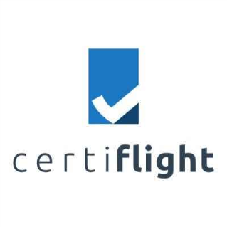

The workshop will take place at the following venue: INCAS – The National Institute for Aerospace Research ”Elie Carafoli”, Iuliu Maniu 220, Sector 6 061126, Bucharest ROMANIA

More information about the project is available at: <https://certiflight.info>